**The University of Newcastle**

**School of Information and Physical Sciences**



**Work Integrated Learning**

**COMP3851A – Semester 1, 2023**

**Project Plan**

*Authors:*

Chen Neen OH

Zayar Bhone Myint

Victor Chua Jia Zhi

Sander Fabian

Brent Lee Ting Zhen  
Cheong Wei Yang

1. **Default Project 2 - Program advisory tool (aka Program Planner)**

Introduction

As a student, visualising a personal education pathway can be difficult. Some students may be confused about choosing their desired pathway as they have a huge variety of options and challenges in the degree pathway system. Students must often explore a complex system, from choosing different courses and majors, to handling their pathway and there can be a lot of pressure on students to choose their academic and professional pathway wisely, especially in a situation when there are seemingly limitless options.

In this project plan, we will address the key components, including the aims, tools, methodology, as well as ethical and intellectual property considerations, pertaining to the development of the Program Advisory Tool. With the goal of providing students with the right direction and making good choices to address these problems, the development of a Program Advisory Tool will be an invaluable tool for students throughout their educational stages.

A Program Advisory Tool helps students select the best preferred programs of study. The tool will generate a pathway according to the student’s preferences in course selection while aligning with the school’s degree requirements. With the assistance of the program advisory tool, students will no longer be confused by the pathways available, and to have the information and freedom to choose their educational and professional paths.

Purpose

The purpose of our eventual product is to allow students of UON to consider their desired pathway efficiently. Additionally, the product will generate a pathway for the students according to their selected program. Another purpose of the product is for the students to be able to see their programs duration, location, term type, total units required for the programs and program requirements.

1. **Background**

Reputable for its excellent research and education, the University of Newcastle is situated in Newcastle, New South Wales, Australia. It was founded in 1965. It collaborates internationally with other schools, provides a wide variety of academic programs, and does exceptionally well in research across multiple fields (Newcastle Austalia, n.d.)

The project is aimed at providing students with an easier method of enrolling in their studies that can be done fully on our website. Currently, the traditional way of enrolling in a course and viewing its pathway is to go to the school’s website, and view each course individually, planning out your pathway and checking if your timetable clashes on your own. The alternative way is to consult your academic advisor personally, either through the phone, through email, or physically.

Our tool is intended to assist students who have completed their diplomas to decide on a course path that will lead them to degree completion or students who wish to pursue honors or masters. The student fills in the courses they have already finished and chooses a program. The path to graduation is then generated based on the course choices of the student, filling in the blanks wherever applicable. After the system generates the pathway, the student can manually switch out courses for those that interest them, and the system verifies the validity of the course choices.

1. **Aims**

Objectives

Our objective is to develop a program advisory tool in the form of a **pathway generator** that will enable students to choose the courses most appropriate for their academic plans and show the duration it will take to complete the generated pathway.

Business issues

**The complexity of curriculum**: From our research, the University of Newcastle offers a range of courses that can be overwhelming when deciding the most appropriate course for their academic goals.

**Inconsistencies of course choices**: Students tend to select courses that are irrelevant to their academic goals, which might delay their graduation path and not benefit their academic goals.

**Poor academic planning**: Students might be unable to create an optimal pathway for their academic plans as there is minimal information to reference, which can result in a longer stay and a disgruntled experience studying at the University of Newcastle.

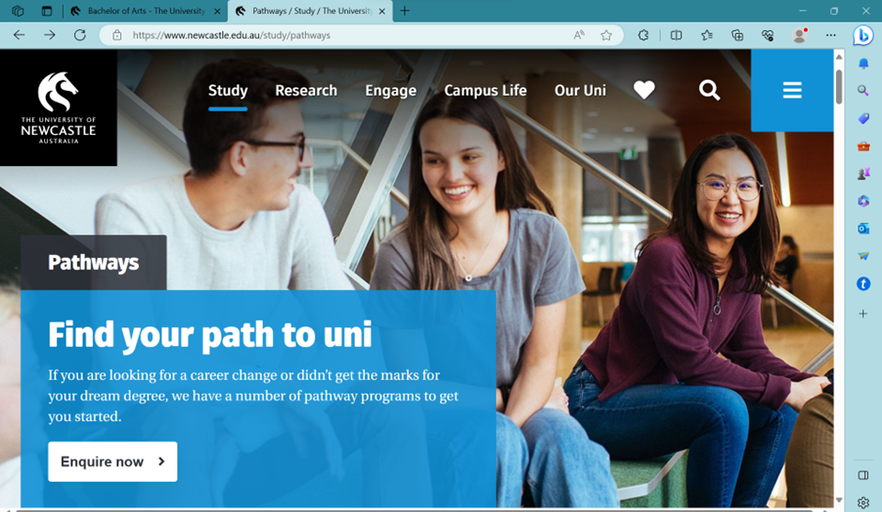

Figure 1: [Pathways / Study / The University of Newcastle, Australia](https://www.newcastle.edu.au/study/pathways)

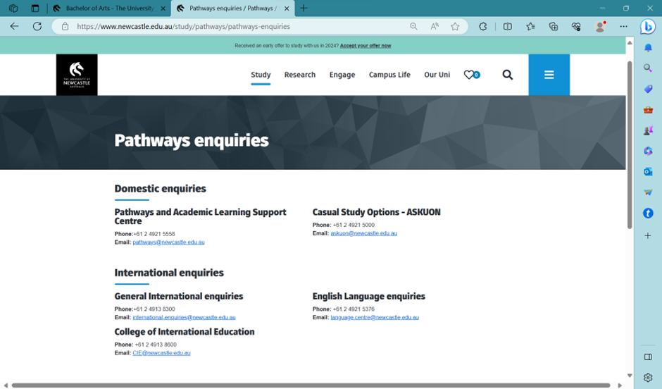

Figure 2: [Pathways enquiries / Pathways / Study / The University of Newcastle, Australia](https://www.newcastle.edu.au/study/pathways/pathways-enquiries)

From our research, we are unable to find any pathway generators from other universities or the University of Newcastle itself. We want to address some of the issues we found on the enquiries page from the University of Newcastle.

1. When clicking on (Figure 1) “Enquire now”, it just re-directs to the pathway enquiries page (Figure 2) and suggests the students contact the school by phone or email. It would be nice for the students to be able to explore the desired programs to see which courses are relevant to their academic goals or at least a reference page to give exposure to the students on which pathway they can take to align with their academic goals.
2. Since the students have no reference to any pathway, they might be clueless and accept any pathway recommended by the school (Figure 2). It would be good to have a pathway generator that shows what relevant courses relate to their selected program and generates a pathway for the student.
3. There would not be any immediate response (Figure 2) as the school requires the student to email them about their enquiries. It would be nice to allow the students to have a pathway generator to allow the students to explore while waiting for the school to contact them.

Based on our research and the identified business issues, our goal is to develop a pathway generator for the University of Newcastle to allow students to see the relevant courses related to their elected program and based on those selected courses, generate a pathway and show the duration of the pathway. This would enhance the student learning experience at the University of Newcastle while mitigating confusion.

1. **Methods and Activities**

**Tools & Platform**

**Interface Prototyping: Figma**

Figma, a collaborative design tool, served as the bedrock of our interface prototyping. It enabled our team members to create interactive prototypes, simplifying the visualization of the user interface's look and feel. (Kopf, n.d.)

Figma was the logical choice for interface prototyping due to its collaborative nature, allowing real-time teamwork, and streamlining the visualization process. It played a pivotal role in designing an engaging and user-friendly interface that aligned seamlessly with our project's goals.

**Moodboard: Canva**

For moodboard creation and consolidation of design ideas, we turned to Canva. This user-friendly design tool allowed us to consolidate our design concepts, promoting consistency and aesthetic appeal throughout the project.

Canva's intuitive design capabilities and ready-to-use templates made it the preferred choice for moodboard creation. By using Canva, our team efficiently collected and consolidated design ideas, ensuring a cohesive design language and a visually pleasing user experience.

**Tools: Awwwards (References), Coolors (Colour Palette)**

Awwwards, a platform recognizing exceptional website designs, served as an invaluable reference for our design inspirations. Coolors, on the other hand, played a significant role in selecting harmonious and engaging colour palettes for our project.

Awwwards provided inspiration and guidance to help us maintain a high standard of design excellence. Coolors ensured that our interface aligned with the University of Newcastle's branding while providing an inviting and user-centric visual experience.

**UML Modelling: Lucidchart**

Lucidchart is a web-based diagramming and UML modelling tool that simplifies the creation of complex UML diagrams, enhancing the precision of our system design. It offers a user-friendly interface for creating several types of UML diagrams, from class diagrams to sequence diagrams.

Lucidchart is selected for its ease of use and collaborative features, allowing our team to work on UML diagrams simultaneously. It streamlines the UML modelling process, ensuring that our system's architecture and interactions are accurately represented. Its collaborative nature facilitates efficient communication and problem-solving within the team, contributing to the success of our project.

**Host: Netlify**

Netlify, a trusted hosting platform, will be chosen to ensure the consistent accessibility and optimal performance of our project. It will be renowned for its focus on speed, security, and scalability. (netlify, n.d.)

Our choice of Netlify will be driven by its ability to provide a reliable and efficient user experience. The platform will ensure the system remains consistently accessible and performs optimally, thereby enhancing user satisfaction.

**Interface: React.js**

The user interface will be developed using React.js, a powerful JavaScript library with a reputation for flexibility and responsiveness. (React, n.d.)

React.js's component-based architecture will allow us to develop a highly responsive and customizable interface. This flexibility will ensure that our project can seamlessly adapt to a variety of user needs and device types, contributing to a remarkable user experience.

**Database: Firebase**

Firebase, a comprehensive cloud-based platform, will serve as the database management solution for our project. It will offer real-time database capabilities and secure authentication features. (Stevenson, 2018)

Firebase's real-time database and secure authentication features will be instrumental in managing and storing user information, course data, and system records. Its scalability will guarantee that our system can accommodate growing user bases while maintaining data integrity and security.

**Version Control: GitHub**

GitHub, a widely embraced version control platform, will serve as our collaborative hub for code management and development. (Kinsta, 2022)

GitHub will facilitate efficient code management, change tracking, issue resolution, and comprehensive documentation. It will promote seamless collaboration among project team members, ensuring harmonious teamwork throughout our project's development journey.

**Methods**

Our project is anchored in the Agile SCRUM methodology, which serves as our project management framework. Agile SCRUM is renowned for its iterative development, collaboration, and adaptability. It ensures that we remain flexible and responsive to changing project requirements while concentrating on delivering incremental value to stakeholders. Our methodology incorporates various elements, including daily standup meetings and backlog meetings. These components promote transparency, team communication, and progress tracking. (Peek, n.d.)

The Agile SCRUM methodology offers numerous advantages, including its flexibility, transparency, and active collaboration. It enables us to adapt swiftly to evolving requirements, maintain transparent project progress, and encourage active collaboration among team members. However, it's important to acknowledge that the methodology can be complex, particularly for teams new to its principles. It may require additional training to fully implement its practices. Additionally, daily standup meetings and regular backlog meetings can be resource-intensive, potentially affecting team members' workloads.

To effectively execute the Agile SCRUM methodology, we leveraged several software tools. Microsoft Teams (MS Teams) served as our central platform for group communication and collaboration, offering real-time chat, file sharing, and collaborative document editing to support our daily standup meetings and ongoing communication. Microsoft Excel played a pivotal role in organizing and managing project-related data efficiently, contributing to effective project management. Incorporating these additional tools into our methodology ensured that our project planning and execution remained structured, collaborative, and efficient. This approach was instrumental in delivering a user-friendly system that aligns with the University of Newcastle's commitment to academic excellence and student success.

5. **Ethics, intellectual property and confidentiality considerations**

In the development and execution of our project, we were acutely mindful of ethical, intellectual property, and confidentiality considerations to ensure that our work adhered to the highest standards of integrity and professionalism.

**Ethics Considerations**

Our project places great importance on ethics considerations. As we embark on enhancing the process for students, we are committed to maintaining the highest ethical standards in all aspects of our work. (Scribbr, n.d.) It is crucial that our efforts align with the principles of fairness, transparency, and respect for the rights and privacy of individuals. Our ethical considerations extend to ensuring that the system respects student privacy, complies with relevant data protection regulations, and offers equal opportunities for all students to access and benefit from the system.

**Intellectual Property**

Intellectual property rights are a paramount concern in our project. We respect and uphold the intellectual property rights of all individuals and entities involved. (Wipo, n.d.) This includes acknowledging and respecting the intellectual contributions and proprietary rights of our team members, collaborators, and any third-party resources we have used. While our project is geared toward enhancing the student experience, we remain committed to safeguarding intellectual property rights and complying with copyright and licensing agreements when integrating external resources.

**Confidentiality Considerations**

Confidentiality is a core principle guiding our project's execution. (Asha, n.d.) We understand the importance of safeguarding sensitive and proprietary information. In this regard, we have implemented strict confidentiality measures to protect any data or information shared with our project team. Our team members are bound by confidentiality agreements, and we have taken steps to ensure that sensitive information is stored securely, accessed only by authorized personnel, and not disclosed to unauthorized individuals. Additionally, we have implemented security measures to safeguard data privacy within our system, ensuring that students' personal and academic information remains confidential and secure.

Our commitment to ethical conduct, respect for intellectual property, and the preservation of confidentiality are integral to our project's success. We uphold these principles to deliver a project that not only streamlines the process for students but also stands as a testament to our dedication to ethical and responsible project execution.

**References**

Asha. (n.d.). Retrieved from <https://www.asha.org/practice/ethics/confidentiality/>

Kinsta. (2022, December 13). *What Is GitHub? A Beginner’s Introduction to GitHub*. Retrieved from <https://kinsta.com/knowledgebase/what-is-github/>

Kopf, B. (n.d.). *The Power of Figma as a Design Tool*. Retrieved from Designers: <https://www.toptal.com/designers/ui/figma-design-tool>

netlify. (n.d.). *A company is as good as its team*. Retrieved from <https://www.netlify.com/about/>

Newcastle Australia. (n.d.). Retrieved from <https://newcastleaustralia.edu.sg/about/#:~:text=The%20University%20of%20Newcastle%20has,teaching%2C%20research%2C%20and%20innovation>.

Peek, S. (n.d.). *What Is Agile Scrum Methodology?* Retrieved from <https://www.businessnewsdaily.com/4987-what-is-agile-scrum-methodology.html>

React. (n.d.). Retrieved from <https://legacy.reactjs.org/>

Scribbr. (n.d.). *What are ethical considerations in research?* Retrieved from <https://www.scribbr.com/frequently-asked-questions/what-are-ethical-considerations-in-research/>

Stevenson, D. (2018, Sep 25). *What is Firebase? The complete story, abridged.* Retrieved from <https://medium.com/firebase-developers/what-is-firebase-the-complete-story-abridged-bcc730c5f2c0>

Wipo. (n.d.). *What is Intellectual Property?* Retrieved from <https://www.wipo.int/about-ip/en/#:~:text=Intellectual%20property%20(IP)%20refers%20to,and%20images%20used%20in%20commerce>